VISUALIZING TIME SERIES DATA

**AIM:** To implement programs for visualizing time series data.

**PROCEDURE AND CODE:**

**Steps 1:**Visualizing the stocks prices over time

fig, axs = plt.subplots(3, 2, figsize=(15, 16)) fig.suptitle('Data by ticker type')

cols = ['Close', 'Adj Close', 'Open', 'High', 'Low', 'Volume'] for i, col in enumerate(cols):

row = i // 2 col = i % 2

for ticker, data in df.groupby('Ticker'):

axs[row, col].plot(data['Date'], data[cols[i]], label=ticker) axs[row, col].set_title(cols[i])

axs[row, col].set_xlabel('Date') axs[row, col].set_ylabel('Price') axs[row, col].legend(loc='right')

axs[row, col].tick_params(axis='x', rotation=45)

plt.tight_layout() plt.subplots_adjust(wspace=0.3, hspace=0.8) plt.show()

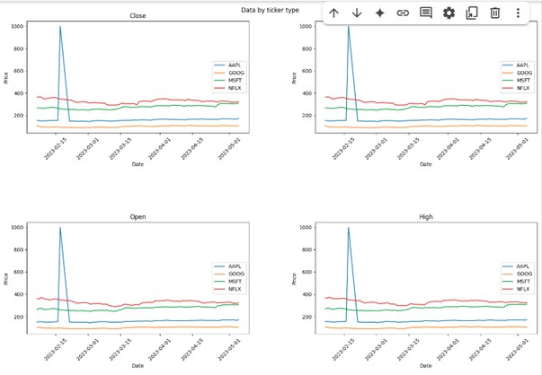

**Step 2:** Visualizing through line plot.

df['Adj Close'].value_counts().sort_values().plot.line()

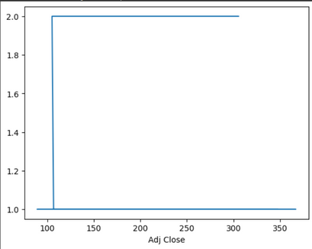

**Steps 3:** Visualizing using bar plot df['Close'].resample('Y').mean().plot.bar()

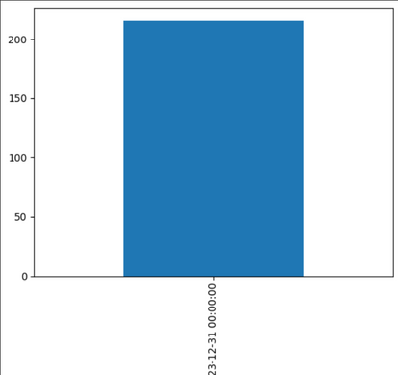

**Steps 6:** Visualizing using lag_plot

from pandas.plotting import lag_plot lag_plot(df['Close'].sample(100))

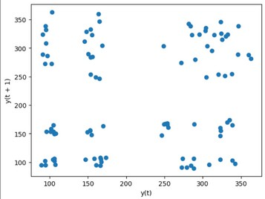

**Steps 7:** Visualizing using autocorrelation_plot.

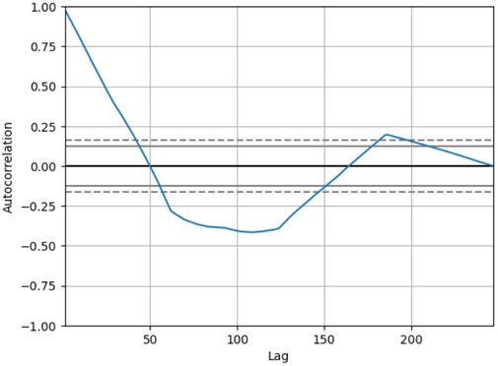

**Result:** The program to implement a program for visualizing time series data is successfully implemented.